POCKETSMART AI
Your Smart Budget & Recommendation Assistant
PROJECT REPORT
Submitted in partial fulfillment of the requirements for
[COURSE / PROGRAM NAME]

Submitted by
[N Archana ]
Register No: [212506764]
Department of [BCA]
[TJS college of Arts and science ]
Academic Year 2026–2027

PROJECT TEAM
Team Leader
N Archana
Team Members
Anusha R
Gayatri K.S
Hemalatha B

CERTIFICATE
This is to certify that the project report entitled “PocketSmart AI: Your Smart Budget & Recommendation Assistant” is a bonafide work carried out by [STUDENT NAME], Register No. [REGISTER NUMBER], of the Department of [DEPARTMENT], [COLLEGE NAME], during the academic year 2026–2027.
The project has been completed under the guidance of [GUIDE NAME] and is submitted as part of the academic requirements of the course.
Place: [PLACE]
Date: [DATE]
Project Guide: N.ARCHANA
Head of Department: SIVARANJANI

DECLARATION
I hereby declare that the project entitled “PocketSmart AI: Your Smart Budget & Recommendation Assistant” is my original academic project work carried out for learning and project submission.
The project has been designed to demonstrate the use of software development, budgeting concepts, recommendation logic, and artificial intelligence assistance in a student-oriented application.
I have prepared this report for academic purposes and have acknowledged relevant technical concepts used in the development of the project.

Name: [N.ARCHANA]

ACKNOWLEDGEMENT
I express my sincere thanks to my project guide, faculty members, and department for their valuable guidance and support throughout the development of PocketSmart AI.
I am grateful to my college for providing the learning environment and resources required to understand application development, databases, budgeting concepts, and artificial intelligence.
I also thank my classmates, friends, and family members for their encouragement and suggestions during the project preparation.
Finally, I thank all the learning resources and software documentation that helped me understand the technical concepts required for this project.

ABSTRACT
PocketSmart AI is a smart budgeting and recommendation assistant designed to help users understand and manage their everyday personal spending. The system allows a user to enter income, expenses, savings goals, and spending categories. Based on the entered information, the application calculates the budget status and provides simple recommendations.
The project combines basic financial calculations with recommendation logic and optional AI assistance. For example, if a user spends more than the planned amount in a category, the system can suggest reducing non-essential spending. If the user has a savings target, the system can calculate a suggested monthly saving amount.
PocketSmart AI can be developed as a web or mobile application. A simple dashboard can show total income, total expenses, remaining balance, savings amount, and category-wise spending. The recommendation module can provide personalized suggestions based on user-provided information.
The system is intended for educational and general budgeting support. It is not a replacement for professional financial advice, investment advice, or banking services.

TABLE OF CONTENTS
1. Introduction
2. Problem Statement
3. Objectives
4. Existing System
5. Proposed System
6. System Requirements
7. System Design and Architecture
8. Modules of PocketSmart AI
9. Budget Calculation and Recommendation Logic
10. AI Assistant Integration
11. Database Design
12. Implementation
13. User Interface and Workflow
14. Testing
15. Advantages and Limitations
16. Future Enhancements
17. Conclusion and References

1. INTRODUCTION
Managing personal money can be difficult when income and expenses are not recorded regularly. Small daily expenses can add up over time, making it difficult for a person to understand where money is being spent. A budgeting application can help users record their transactions and view their financial position.
PocketSmart AI is proposed as a simple smart budgeting assistant. It focuses on three main activities: recording financial information, analyzing the budget, and giving understandable recommendations.
The system can categorize expenses such as food, transport, education, shopping, entertainment, bills, and other needs. Users can set a monthly budget and savings goal. The application compares actual spending with planned spending and displays the difference.
The AI or recommendation component can convert the analysis into simple suggestions. For example, it can say that a particular category is above the user's planned budget and suggest reviewing non-essential expenses.
The project demonstrates how ordinary software calculations can be combined with intelligent recommendations to create a useful personal budgeting application.

2. PROBLEM STATEMENT
Many users do not maintain a clear record of their daily spending. Without a proper record, it is difficult to know how much money has been spent, which categories consume the most money, and how much can be saved.
Common problems include:
- Not recording small daily expenses.
- Difficulty calculating total monthly expenses.
- Unclear understanding of category-wise spending.
- Difficulty setting realistic savings targets.
- Manual calculation of remaining budget.
- Limited personalized recommendations.
- Difficulty identifying unnecessary or excessive spending.
PocketSmart AI addresses these problems by providing a single interface for entering financial information, calculating budget status, and receiving simple recommendations.

3. OBJECTIVES OF THE PROJECT
The main objective of PocketSmart AI is to develop a simple and user-friendly budgeting assistant that helps users monitor spending and make better day-to-day budgeting decisions.
- Record income and expenses.
- Categorize expenses automatically or manually.
- Calculate total income and expenses.
- Display remaining balance.
- Set monthly budgets for categories.
- Set savings goals.
- Compare planned and actual spending.
- Generate personalized budgeting recommendations.
- Provide simple charts and summaries.
- Offer an AI-based conversational assistant for budgeting questions.
- Maintain transaction history for analysis.
The project also aims to provide practical experience in frontend development, backend programming, database management, calculation logic, recommendation systems, and responsible use of AI.

4. EXISTING SYSTEM
In a traditional approach, users may maintain expenses in notebooks, spreadsheets, calculator applications, or separate banking applications. These methods can record information, but the user may still need to manually analyze the data.
A spreadsheet can calculate totals, but creating personalized recommendations requires additional formulas or manual interpretation. A basic expense tracker may record transactions but may not explain why the spending pattern matters.
Limitations of the existing approach:
- Manual entry and analysis can be time-consuming.
- Users may forget to record expenses.
- Information may be spread across multiple applications.
- Basic trackers may not provide recommendations.
- Users may find financial reports difficult to understand.
- Budget planning and savings calculations may require manual work.
PocketSmart AI adds a recommendation layer to make the information easier to understand and act upon.

5. PROPOSED SYSTEM
The proposed PocketSmart AI system provides a dashboard where users can enter income, expenses, budgets, and savings goals. The application stores the information and performs calculations automatically.
Main workflow:
- User creates or opens a personal budget.
- User enters income and expenses.
- Expenses are assigned to categories.
- System calculates totals and remaining balance.
- System compares spending with category budgets.
- Recommendation engine identifies useful suggestions.
- AI assistant can explain the budget in natural language.
- Dashboard displays results using cards, tables, or charts.
The system should avoid making high-risk financial decisions for the user. Recommendations can focus on basic budgeting, spending awareness, and savings planning.
Example: If monthly income is ₹25,000 and recorded expenses are ₹18,000, the application can show ₹7,000 as the current remaining balance before considering any other planned commitments.

6. SYSTEM REQUIREMENTS
Hardware Requirements
- Computer or laptop with at least 4 GB RAM.
- Keyboard and mouse/touchpad.
- Stable internet connection for optional AI features.
- Mobile device may be used if a mobile version is developed.
Software Requirements
- Operating System: Windows, Linux, macOS, Android, or other supported platform.
- Frontend: HTML, CSS, JavaScript or a suitable framework.
- Backend: Python, JavaScript/Node.js, Java, or another suitable technology.
- Database: SQLite, MySQL, PostgreSQL, Firebase, or another suitable database.
- Code editor such as Visual Studio Code.
- Modern web browser for a web implementation.
Optional AI Requirement
An AI API or locally hosted model can be connected to the recommendation assistant. API credentials must be stored securely and must not be placed directly in public frontend code.

7. SYSTEM DESIGN AND ARCHITECTURE
PocketSmart AI can follow a three-layer architecture.
1. Presentation Layer: Provides the dashboard, transaction form, budget form, charts, recommendation cards, and AI chat interface.
2. Application Layer: Validates user inputs, performs calculations, applies recommendation rules, communicates with the database, and optionally calls an AI service.
3. Data Layer: Stores user profiles, transactions, categories, budgets, savings goals, and recommendation history.
Architecture Flow:
User → Frontend → Backend → Database
↓
Recommendation Engine
↓
AI Service
↓
Recommendation
The backend should validate numerical values, prevent invalid transactions, and handle database or AI-service errors safely.
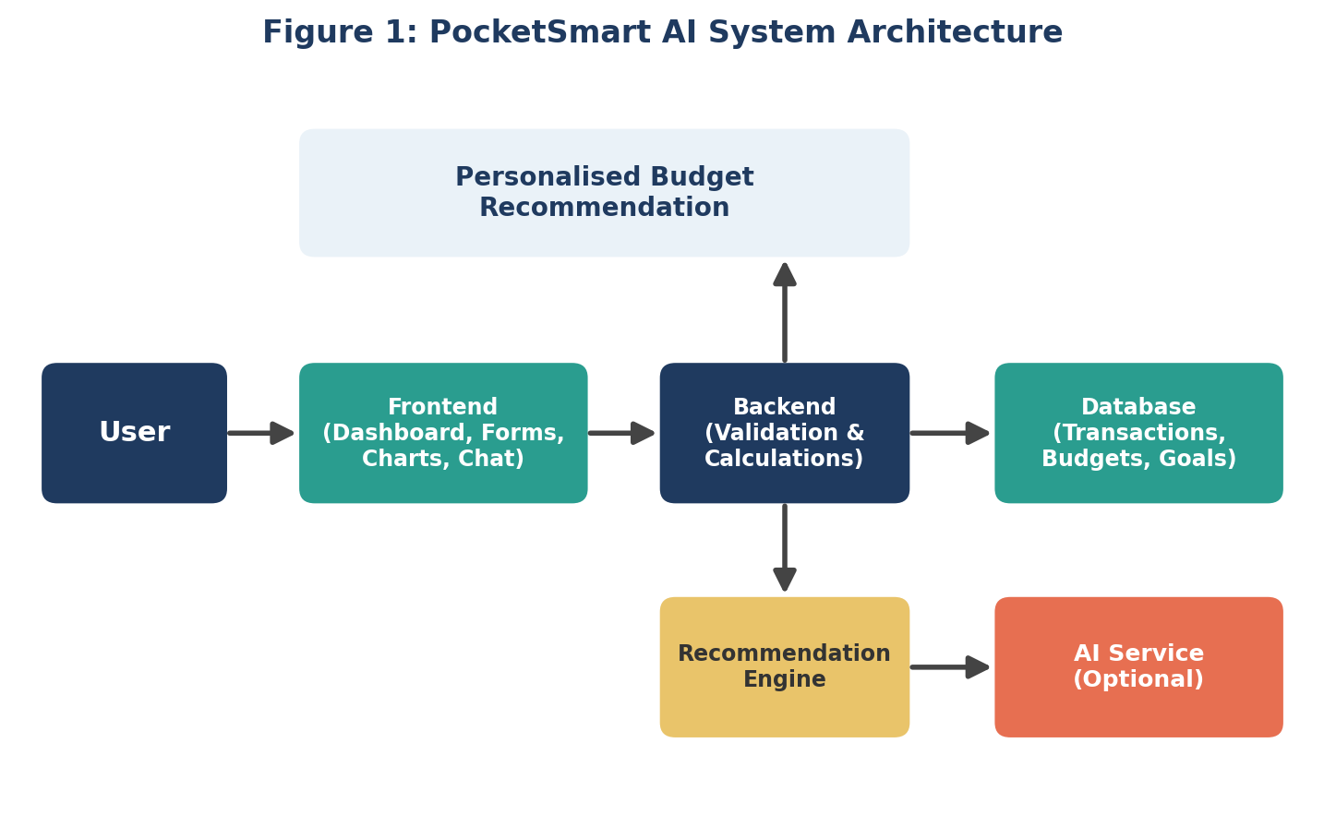

8. MODULES OF POCKETSMART AI
Module 1 – User Profile
Stores basic application information and preferences required for the budgeting dashboard.
Module 2 – Income Management
Allows the user to record salary, allowance, freelance income, or other income sources.
Module 3 – Expense Management
Allows users to enter amount, date, description, and category for each expense.
Module 4 – Budget Management
Users can define monthly limits for categories such as food, transport, education, and entertainment.
Module 5 – Savings Goal
Users can enter a target amount and target date. The system can calculate a suggested periodic saving amount.
Module 6 – Recommendation Engine
Analyzes spending and generates rule-based suggestions.
Module 7 – AI Assistant
Allows users to ask natural-language budgeting questions and receive explanations based on the available information.
Module 8 – Reports
Displays summaries, category totals, budget differences, and simple charts.

9. BUDGET CALCULATION AND RECOMMENDATION LOGIC
Basic Budget Calculation
Remaining Balance = Total Income − Total Expenses
Budget Difference = Category Budget − Category Spending
If the budget difference is positive, the spending is below the selected limit. If it is negative, the category has exceeded the selected limit.
Savings Calculation
Suggested Monthly Saving = Savings Goal Amount ÷ Number of Months
Example: If a user wants to save ₹12,000 in 6 months, the simple suggested monthly saving is ₹2,000.
Recommendation Rules
- If category spending is above its budget, recommend reviewing that category.
- If total expenses are close to total income, recommend checking non-essential expenses.
- If a savings target is active, show the required periodic saving amount.
- If spending decreases for a period, display a positive progress message.
- If transaction data is incomplete, ask the user to update missing information.
The project should present these as suggestions rather than mandatory financial instructions.
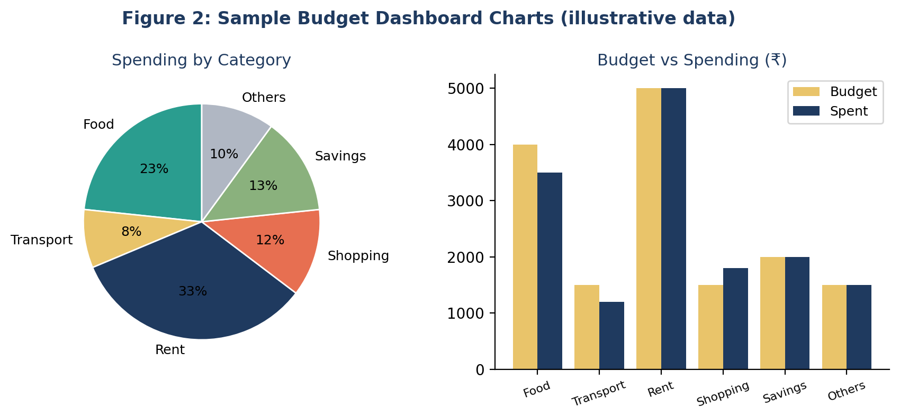

10. AI ASSISTANT INTEGRATION
The AI assistant can provide a conversational interface over the budgeting data. Instead of displaying only numbers, the system can explain the results in simple language.
Example user prompt:
“My monthly income is ₹30,000 and my expenses are ₹22,000. Explain my current budget position simply.”
Example response style:
“Your recorded expenses are ₹22,000, so your current remaining balance is ₹8,000. Review upcoming bills and savings goals before treating the full balance as available spending money.”
For a real implementation, the application should send only the minimum required data to the AI service. Sensitive information such as passwords, bank credentials, card numbers, PINs, or authentication codes should never be included in prompts.
AI output should be treated as assistance. The application should not claim that an AI-generated recommendation is guaranteed to improve a user's finances.

11. DATABASE DESIGN
A simple relational database can contain the following tables.
Users Table
- user_id
- name
- email or login identifier
- created_date
Transactions Table
- transaction_id
- user_id
- type
- amount
- category
- description
- transaction_date
Budgets Table
- budget_id
- user_id
- category
- limit_amount
- month
Savings Goals Table
- goal_id
- user_id
- goal_name
- target_amount
- saved_amount
- target_date
Recommendations Table
- recommendation_id
- user_id
- message
- category
- created_date
Relationships ensure that each user's transactions, budgets, and goals can be retrieved for analysis. Database access should use appropriate authentication and authorization controls.

12. IMPLEMENTATION AND USER WORKFLOW
Step 1: Create the dashboard with sections for income, expenses, budget, savings, and recommendations.
Step 2: Create forms for entering transactions. Validate that amounts are positive numbers and required fields are present.
Step 3: Store transactions in the database.
Step 4: Calculate total income, total expenses, category totals, and remaining balance.
Step 5: Compare category spending with category budgets.
Step 6: Run the recommendation rules and display suitable suggestions.
Step 7: Connect the optional AI assistant to explain the budget using a secure backend.
Step 8: Add charts such as a category spending chart and monthly expense trend.
Step 9: Test the application using normal, invalid, empty, and large-value inputs.
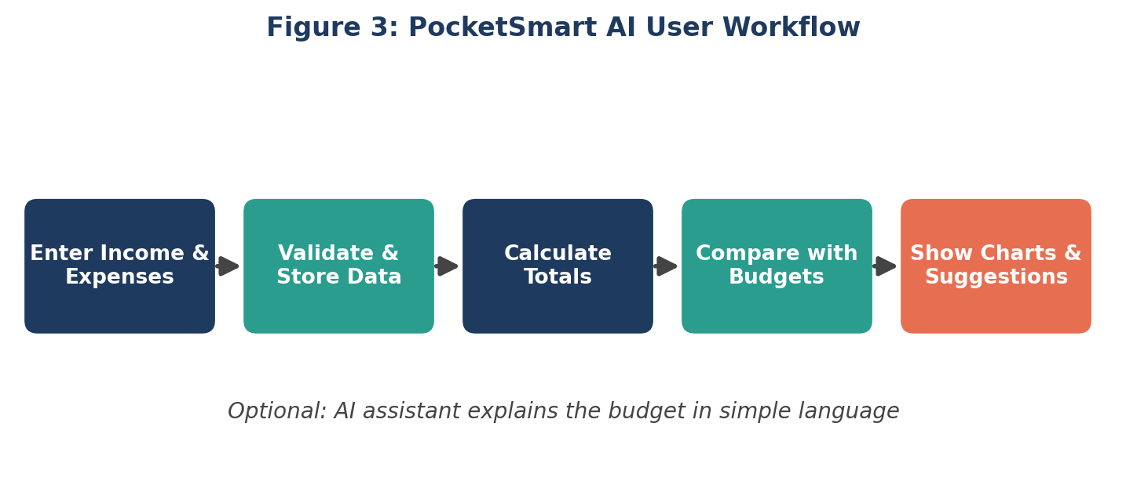
Example pseudocode:
income = get_total_income()
expenses = get_total_expenses()
balance = income - expenses
for category in categories:
spending = get_category_spending(category)
budget = get_category_budget(category)
if spending > budget:
recommend("Review " + category + " spending")

13. TESTING, ADVANTAGES AND LIMITATIONS
Testing
- Valid income entry → income is stored and displayed.
- Valid expense entry → expense is stored and included in totals.
- Empty amount → validation message is displayed.
- Negative amount → input is rejected.
- Budget exceeded → recommendation is generated.
- Savings goal entered → suggested periodic saving is calculated.
- AI service unavailable → friendly error message is shown.
- Unauthorized access → private budget data is protected.
Advantages
- Simple and user-friendly budgeting.
- Automatic calculations reduce manual work.
- Category-wise spending visibility.
- Personalized recommendations.
- Can combine rule-based logic with AI.
- Can be expanded into a mobile or web application.
Limitations
- Recommendations depend on the accuracy of user-entered data.
- AI responses can be incorrect or incomplete.
- Online AI features may require internet access.
- API usage may have limits or costs.
- The project is not a replacement for professional financial advice.

14. FUTURE ENHANCEMENTS, CONCLUSION AND REFERENCES
Future Enhancements
- Automatic receipt scanning and expense extraction.
- Voice-based expense entry.
- Multilingual budgeting assistant.
- Bank or payment-account integrations where appropriate and securely supported.
- Advanced spending analytics and trend detection.
- Personalized savings reminders.
- Family or shared-budget support.
- Offline-first mobile application.
- Improved privacy controls and encrypted sensitive data.
Conclusion
PocketSmart AI demonstrates how a budgeting application can combine financial calculations, structured data, recommendation rules, and AI-based conversation to support everyday money management. The system helps users understand income, expenses, budgets, savings goals, and spending patterns through a simple dashboard.
The project provides practical experience in software design, database management, frontend and backend development, recommendation logic, testing, and responsible AI integration. PocketSmart AI should be used as a budgeting support tool, while important financial decisions should be made carefully using reliable information and, when appropriate, qualified professional advice.
References
1. General software engineering and database design learning materials.
2. Official documentation of the programming language, database, frontend framework, and AI API selected for implementation.
3. Project-specific design, testing, and implementation notes.
Replace [STUDENT NAME], [REGISTER NUMBER], [COLLEGE NAME], [DEPARTMENT], [GUIDE NAME], [PLACE], and [DATE] before submission.

